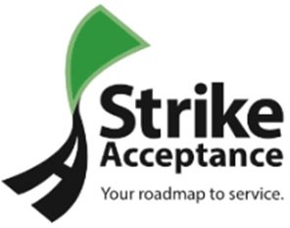

Loan Application Number: ________________________

Your loan package has been submitted to Strike Acceptance for final approval

Finalizing Your Loan
- Strike is going to contact you in the next 24 to 72 hours. We will call you from (949) 371-8656 or another 949-area code phone number. It is important you answer the phone or return the call at your earliest convenience.

- We need to verify your employment. Please contact your Human Resources Department and request they verify your employment as soon as possible.

Once Your Loan is Finalized
- Within 3 business days we will mail you a Welcome Package to your address on file.

- Your first payment date is listed on your Contract. All payments must be made on or before your due date. We do not have a grace period.

- A payment may be made by mail, online, by phone, or you may select automatic withdrawal using your checking account. Payments made by mail or automatic withdrawal are free of charge. All other payments incur a $4.95 processing fee.

- If your vehicle is ever impounded or involved in an accident, please contact us immediately so we may try and assist you.

- If the Check Engine light for your vehicle comes on or you experience any other significant mechanical issue, please contact us immediately.

We are excited for your purchase and look forward to helping you build your credit
Mail payments to:
Strike Acceptance Inc.
PO Box 849605
LOS ANGELES, CA 90084-9605
** Please include your account number

Hours of Operation:
Monday - Friday – 8:00 am – 8:30 pm (CST)
Saturday – 8:00 am – 7:00 pm (CST)
Sunday – Closed
P. (949) 371-8656

Email: customerservice@strikeacceptance.com

